**Test Summary Report**

**Project Name**: Personal Learning Project - Manual Testing of OpenCart E-commerce Platform  
**Prepared by**: Bharg Goswami  
**Date**: 7th July, 2025  
**Version**: 1.0

**1. Project Overview**

* **Objective**: To validate core functionalities of the OpenCart demo site (<https://demo.opencart.com/>) as part of a personal learning initiative for my first QA job application.
* **Test Period**: 20th June, 2025 – 7th July, 2025
* **Environment**: Tested on Opera & Chrome browsers using OpenCart Frontend demo Site (<https://demo.opencart.com/>).
* **Tools Used**: Excel for Test cases, Test Case Execution, RTM, Test Scenarios & BUG Reporting and Word for Test Summary Report, Test Plan, FRS Document.

**2. Test Scope**

* **Functionalities Tested**: Register, Login, Logout, Search, Add to Cart, Wish list, Homepage, My Account, Checkout & Shopping Cart.
* **Total Planned Test Cases**: 100 (10 per functionality).

**3. Test Execution Metrics**

| **Metric** | **Value** | **Details** |
| --- | --- | --- |
| **Total Number of Tests Performed** | 100 | All 100 test cases executed across 10 functionalities. |
| **Count of Tests Not Performed but Skipped** | 0 | No test cases were skipped; all planned tests completed. |
| **Count of Passed Tests** | 94 | 94 test cases passed successfully. |
| **Count of Failed Tests** | 6 | 6 test cases failed, logged as Bugs. |
| **Percentage of Successful Tests** | 94% | (94 passed / 100 total) * 100. |
| **Percentage of Unsuccessful Tests** | 6% | (6 failed / 100 total) * 100. |
| **Defect Detection Rate** | 6% | Percentage of tests resulting in Bug. |

**4. Test Results by Functionality**

| **Functionality** | **Total Test Cases** | **Passed** | **Failed** | **Pass %** | **Comments** |
| --- | --- | --- | --- | --- | --- |
| Register | 10 | 8 | 2 | 80% | 2 failures due to invalid input handling. |
| Login | 10 | 10 | 0 | 100% | No issues detected. |
| Logout | 10 | 9 | 1 | 90% | 1 failure in multi-device logout. |
| Search | 10 | 10 | 0 | 100% | No issues detected. |
| Add to Cart | 10 | 9 | 1 | 90% | 1 failure with invalid quantity. |
| Wish list | 10 | 10 | 0 | 100% | No issues detected. |
| Homepage | 10 | 10 | 0 | 100% | No issues detected. |
| My Account | 10 | 9 | 1 | 90% | 1 failure with Site Map navigation. |
| Checkout | 10 | 10 | 0 | 100% | No issues detected. |
| Shopping Cart | 10 | 9 | 1 | 90% | 1 failure with invalid quantity update. |
| **Total** | **100** | **94** | **6** | **94%** |  |

**5. Defects Identified**

| **Defect ID** | **Description** | **Severity** | **Status** | **Associated Test Case** |
| --- | --- | --- | --- | --- |
| Opencart_BUG_01 | User can register with an invalid phone number | Medium | Open | Register (2 failures) |
| Opencart_BUG_02 | Red * sign for mandatory fields missing except Privacy Policy | Low | Open | Register (2 failures) |
| Opencart_BUG_03 | Logout from one device doesn’t log out on another device | Medium | Open | Logout (1 failure) |
| Opencart_BUG_04 | Invalid quantity (-1) for Add to Cart shows success message | Critical | Open | Add to Cart (1 failure) |
| Opencart_BUG_05 | My Account from Site Map logs out with invalid token warning | High | Open | My Account (1 failure) |
| Opencart_BUG_06 | Invalid quantity (-1) update in Shopping Cart shows success message | High | Open | Shopping Cart (1 failure) |

* **Total Defects Reported**: 6
* **Severity Breakdown**: 1 Critical, 2 High, 2 Medium, 1 Low.

**6. Analysis and Observations**

* **Strengths**: 94% pass rate indicates robust functionality for most features (Login, Search, Checkout, etc.).
* **Weaknesses**: Key issues in Register (invalid phone handling), Logout (multi-device sync), Add to Cart, My Account, and Shopping Cart (quantity validation) need attention.
* **Defect Trends**: Invalid input handling (e.g., quantity, phone) is a recurring issue, suggesting potential validation logic gaps.

**7. Recommendations**

* Retest failed functionalities after defect fixes by the development team.
* Expand testing with edge cases & Exploratory Testing (e.g., special characters in phone/email fields).
* Automate repetitive tests (e.g., Login, Search) using free tools like Selenium IDE after mastering manual testing.

**8. Conclusion**

This personal learning project successfully validated 10 OpenCart functionalities with a 94% pass rate, identifying 6 defects logged. The experience enhanced my understanding of manual testing, test case execution, and defect reporting, making me ready for entry-level QA roles.   
  
This report and associated artifacts are available on my GitHub repository:

**9. Attachments**

* Defect Logs (Excel File: Defect_Report_OpenCart.xlsx Screenshot) **(Page No. 4)**
* RTM (Excel File: OpenCart_RTM.xlsx Snip Screenshot) **(Page No. 4)**
* Screenshots of Failed Test Cases **(Page No. 5 To 10)**  
    
  (Screenshots In Next Pages)
  1. **Defect Logs**

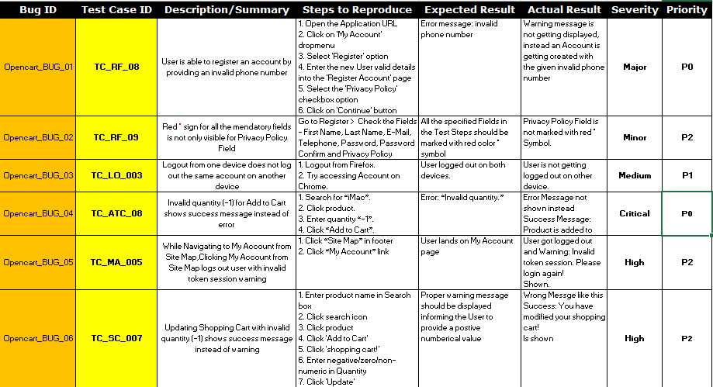

* 1. **RTM (Snip Screenshot)**

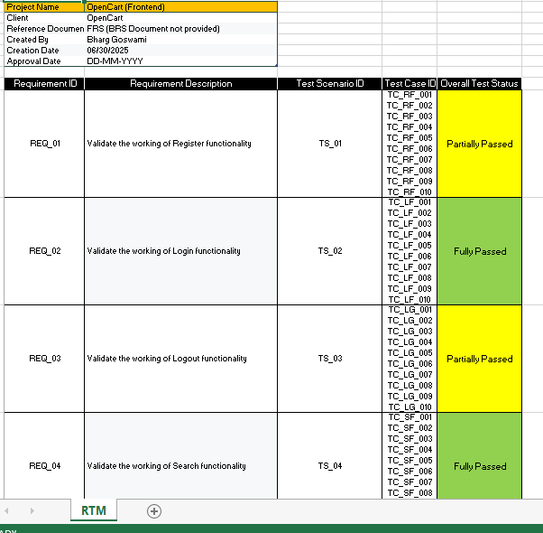

* 1. **Screenshots of Failed Test Cases**

1. User is able to register an account by providing an invalid phone number

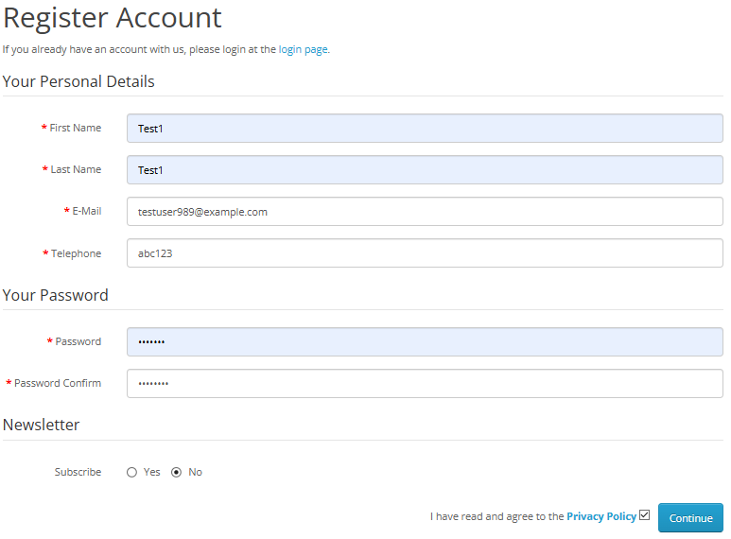



2. Red * sign for all the mendatory fields is not only visible for Privacy Policy Field

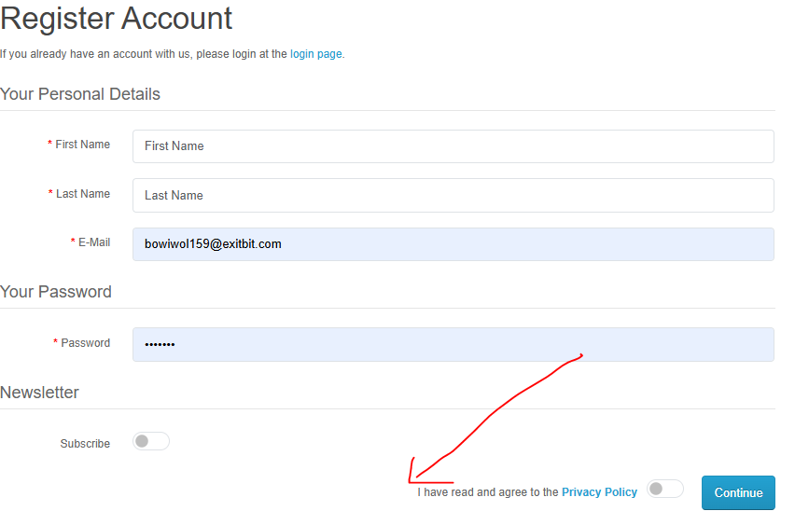

3. Logout from one device does not log out the same account on another device

A. LOGOUT FROM SAME ACCOUNT IN OPERA BROWSER

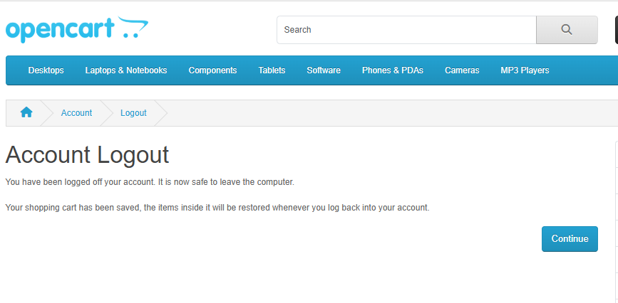  
2. STILL LOGGED IN WITH SAME ACCOUNT IN CHROME BROWSER AFTER LOGOUT IN OPERA BROWSER

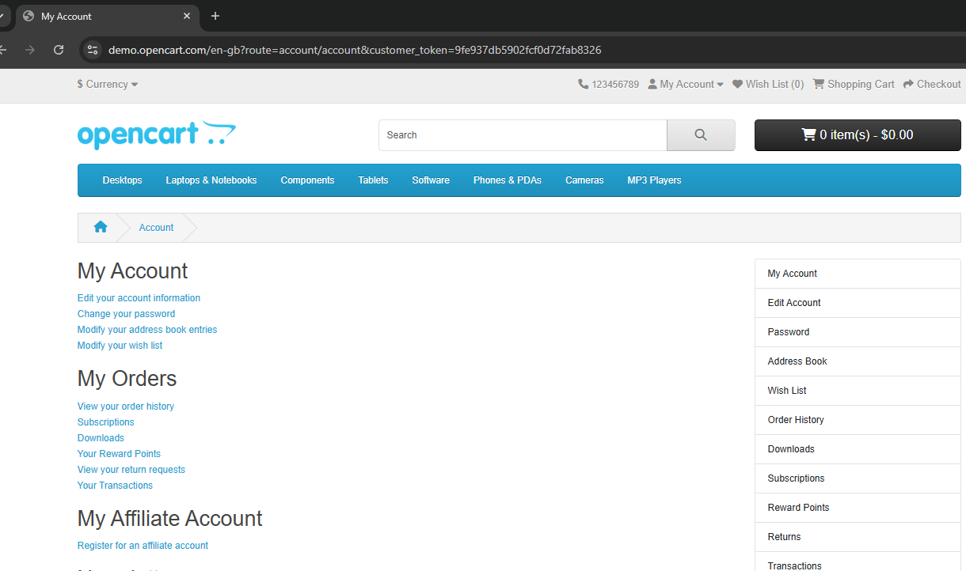

4. Invalid quantity (-01010101) for Add to Cart shows success message instead of error

A.AFTER ENTERING INVALID QUANTITY  
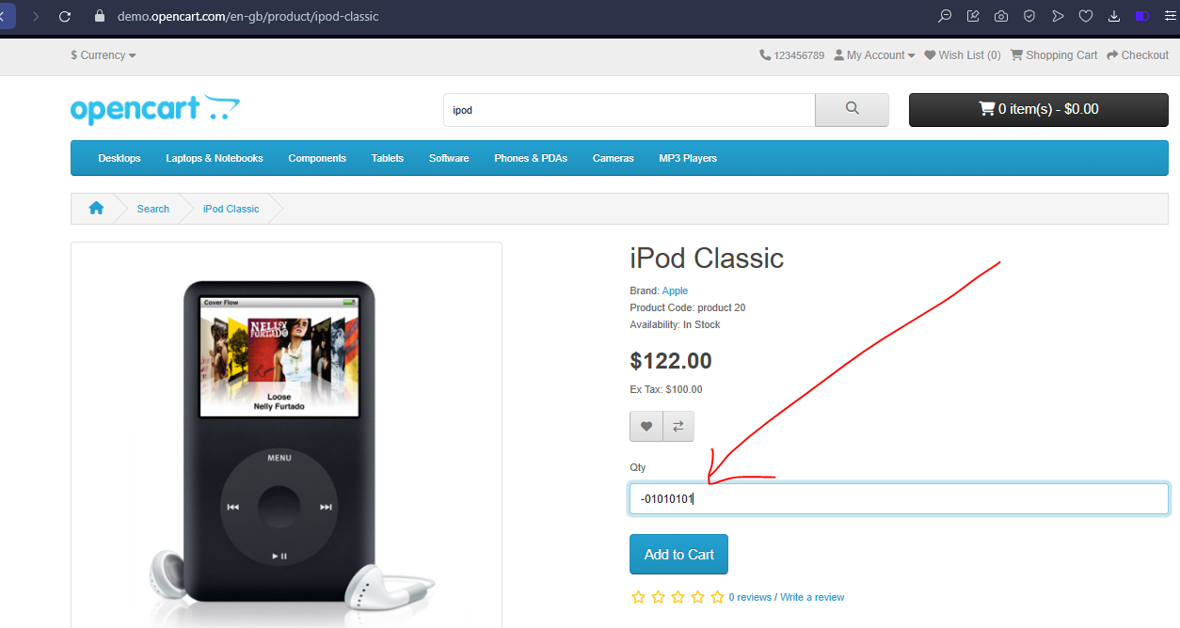

B. AFTER CLICKING ADD TO CART

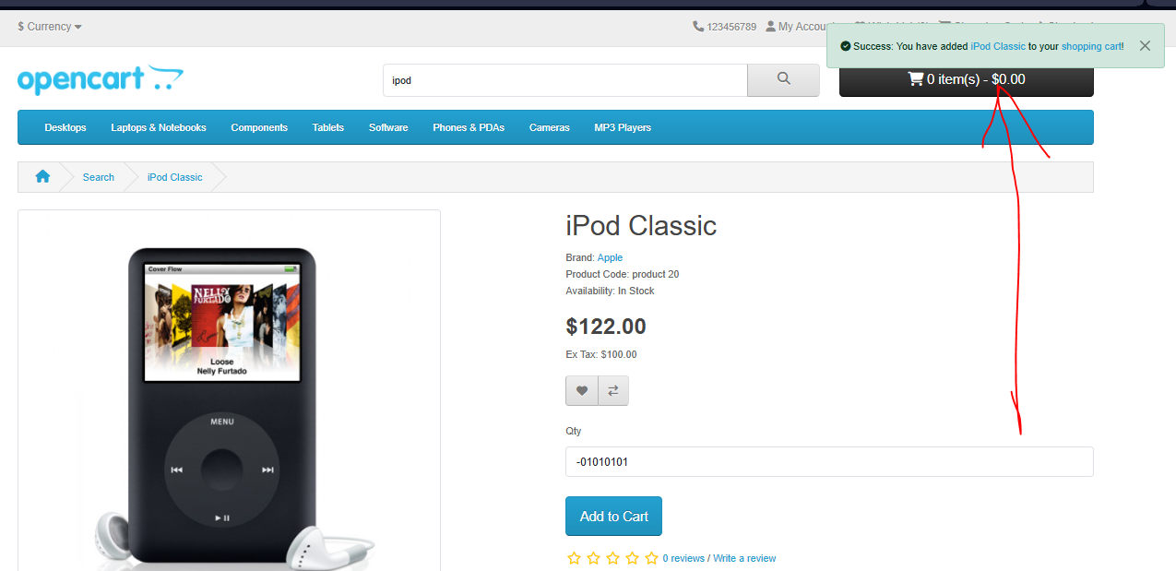

5. While Navigating to My Account from Site Map, Clicking My Account from Site Map logs out user with invalid token session warning

A. SITEMAP PAGE BEFORE CLICKING “MY ACCOUNT”

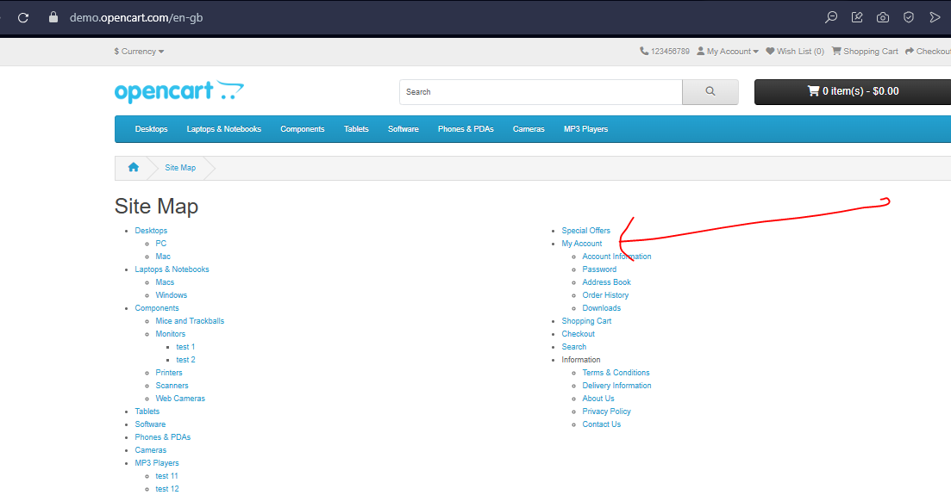

B. AFTER CLICKING “MY ACCOUNT” IN SITEMAP

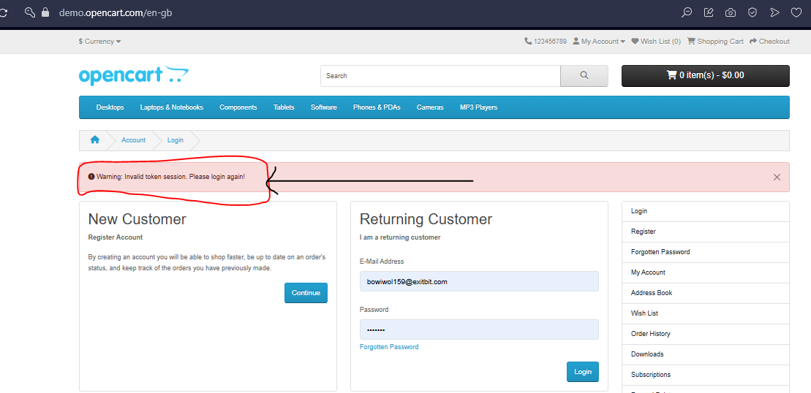

6. Updating Shopping Cart with invalid quantity (-1) shows success message instead of warning

A. ENTERING 0 IN QUANTITY OF ADDED PRODUCT BEFORE CLICKING UPDATE ICON IN SHOPPING CART PAGE

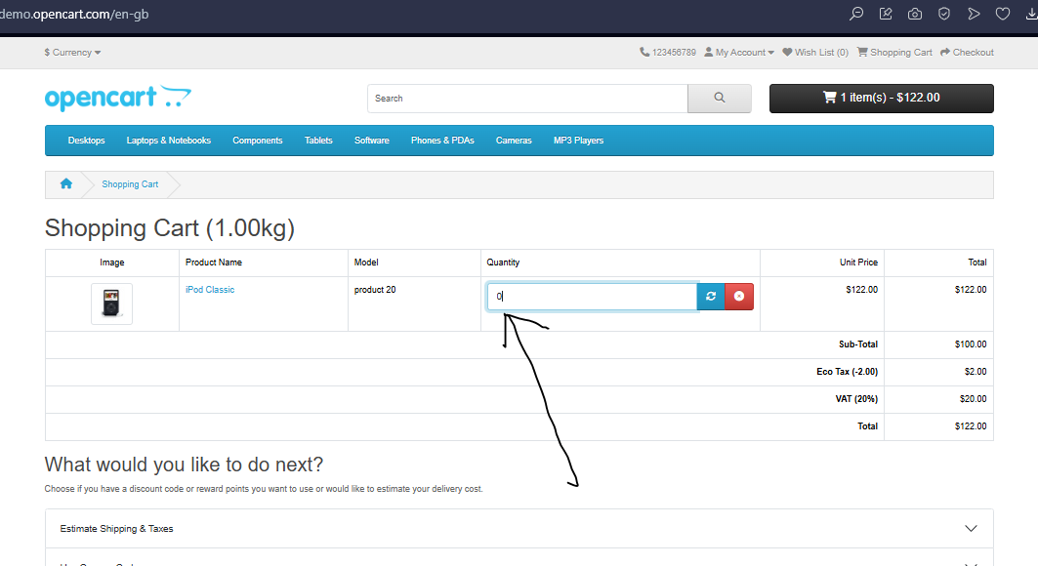

B. AFTER CLICKING UPDATE ICON ADDED ITEM DISAPPEARED & SUCCESS MESSAGE SHOWN  
